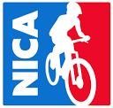
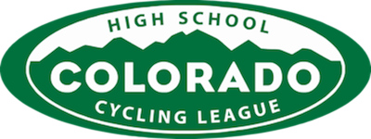
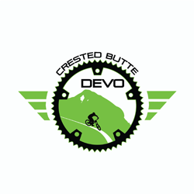

Pinning Standards for CB Devo HSRT Student Athletes
I.) Background: Since 2010, the Colorado High School Cycling League, organized under the guidance of the National Interscholastic Cycling Association (NICA), has run a statewide series of mountain bike races for high school age participants. The Cycling League has grown to over 1400 cyclists representing approximately 80 registered teams from Colorado, Wyoming, and New Mexico. Riders compete in a four- race series that will culminate in Durango, CO for a fifth race to crown a state champion for both team and individual riders. Racers and school teams earn points at each event based on their finishing place within the following categories: Male and female divisions. Freshman, sophomore, junior varsity, varsity levels. Points accumulated by riders/racers throughout the season (based on their 3 best point finishes) are awarded ‘Season Awards’. All participants are expected to adhere to the NICA Five Core Principles at all times during practice and races:
Inclusivity, Equality, Strong Body, Strong Mind and Strong Character.
II.) Proposal: The coaches, parent volunteers and Board of Directors of the Crested Butte Devo High School Race Team are proposing that student-athletes that are participating on the Crested Butte Devo High School Race Team earn a ‘Pin’ by meeting the following criteria:
- Good academic standing: letter grades in all classes be a “C” or better
- Race 4 of 4 races in varsity, junior varsity, sophomore or freshman racing categories or qualify and compete at the State Championships
- ZERO unexcused absences from team practices
- Complete 10 hours of volunteer work, includes junior mentoring and team trail workday with C.B.M.B.A. as well as other community volunteer opportunities
- Full Compliance with NICA, Colorado High School Mountain Bike League and Crested Butte Development Team performance and conduct guidelines
- Coaches discretion: Letter can be awarded outside these guidelines in special circumstances

lll.) Recognition: CB Devo head coaches will be taking attendance at practices and races as well as observing other behaviors to be sure criteria 2, 3 and 5 are met above. However, in order to receive this pin, parents and athletes must sign below acknowledging that the rider receiving this recognition has maintained the academic standards throughout the first semester (#1. above) and completed 10 hours of volunteer work (#4. above) before the end of the season, October 20. These criteria will follow the honor system as we believe this to be the most successful way to proceed with these requirements.

_____________________________________________________________________
Athlete Signature Parent Signature Date

Thank you for supporting these standards.

Torrey Carroll, Crested Butte Devo HSRT Co-Head Coach
Jenny Smith, Crested Butte Devo HSRT Co-Head Coach
Amy Nolan, Crested Butte Devo Executive Director

