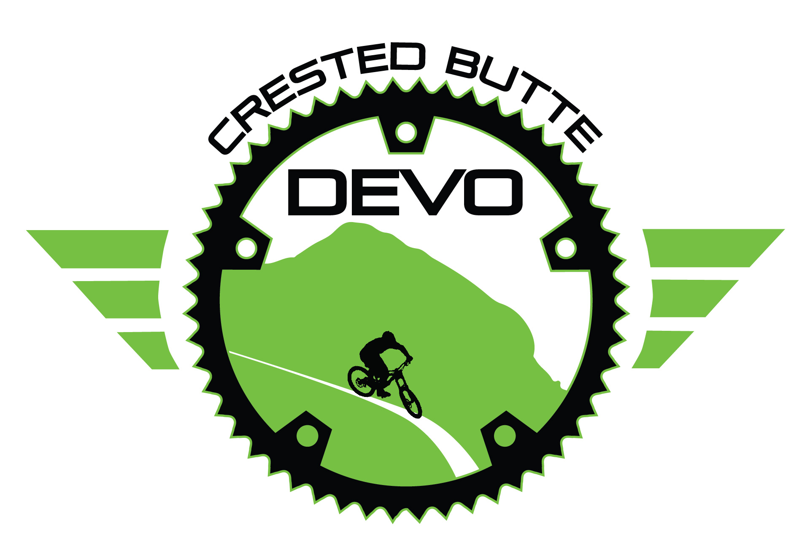
CRESTED BUTTE DEVELOPMENT TEAM 2020
Waiver/Release for Communicable Diseases Including COVID-19
In consideration of being allowed to participate on behalf of Crested Butte Development Team programs and related events and activities, the undersigned acknowledges, appreciates, and agrees that:
1. Participation includes possible exposure to and illness from infectious diseases including but not limited to MRSA, influenza, and COVID-19. While particular rules and personal discipline may reduce this risk, the risk of serious illness and death does exist; and,
2. I KNOWINGLY AND FREELY ASSUME ALL SUCH RISKS, both known and unknown, EVEN IF ARISING FROM THE NEGLIGENCE OF THE RELEASEES or others, and assume full responsibility for my participation; and,
3. I willingly agree to comply with the stated and customary terms and conditions for participation as regards protection against infectious diseases. If, however, I observe and any unusual or significant hazard during my presence or participation, I will remove myself from participation and bring such to the attention of the nearest official immediately; and,
4. I, for myself and on behalf of my heirs, assigns, personal representatives and next of kin, HEREBY RELEASE AND HOLD HARMLESS Crested Butte Development Team their officers, officials, agents, and/or employees, other participants, sponsors, and owners and lessors of premises used to conduct the event (“RELEASEES”), WITH RESPECT TO ANY AND ALL ILLNESS, DISABILITY, DEATH, or loss or damage to person or property, WHETHER ARISING FROM THE NEGLIGENCE OF RELEASEES OR OTHERWISE, to the fullest extent permitted by law.

THIS IS TO CERTIFY THAT I, AS PARENT/GUARDIAN, WITH LEGAL RESPONSIBILITY FOR THIS PARTICIPANT, HAVE READ AND EXPLAINED THE PROVISIONS IN THIS WAIVER/RELEASE TO MY CHILD/WARD INCLUDING THE RISKS OF PRESENCE AND PARTICIPATION AND HIS/HER PERSONAL RESPONSIBILITIES FOR ADHERING TO THE RULES AND REGULATIONS FOR PROTECTION AGAINST COMMUNICABLE DISEASES. FURTHERMORE, MY CHILD/GUARDIAN UNDERSTANDS AND ACCEPTS THESE RISKS AND RESPONSIBILITIES. I FOR MYSELF, MY SPOUSE, AND CHILD/GUARDIAN DO CONSENT AND AGREE TO HIS/HER RELEASE PROVIDED ABOVE FOR ALL THE RELEASEES AND MYSELF, MY SPOUSE, AND CHILD/WARD DO RELEASE AND AGREE TO INDEMNIFY AND HOLD HARMLESS THE RELEASEES FOR ANY AND ALL LIABILITIES INCIDENT TO MY MINOR CHILD’S/WARD’S PRESENCE OR
PARTICIPATION IN THESE ACTIVITIES AS PROVIDED ABOVE, EVEN IF ARISING FROM THEIR NEGLIGENCE, TO THE FULLEST EXTENT PROVIDED BY LAW.
RIDER(S) NAME(S):_________________________________________________________________________________
RIDER(S) BIRTHDATE(S): ______________________________________ AGE(S): ________________________________
PARENT/GUARDIAN NAME (PRINTED): _________________________________________________________________
PARENT/GUARDIAN SIGNATURE: ______________________________________ DATE: __________________________
PARENT/GUARDIAN PHONE #: ________________________________________ EMAIL:_________________________

